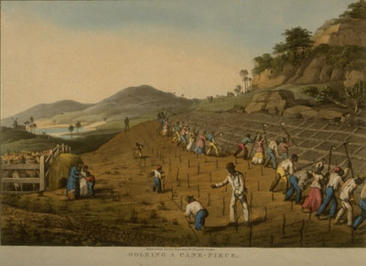

Task 1: Starter Activity

Sum up each image with a headline.
- Why did you pick your heading?

- What can be said of the relationship between white masters and black slaves?

- With the number of slaves and their tools, how did whites maintain their control?

- Are there obvious gender division in the work force?

- What are the risks present to the slaves in sugar production?

- What stage of sugar production would be safest to work in?

Digging Holes for Planting Sugar Cane, Antigua, West Indies, 1823.
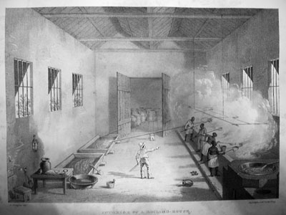
Sugar boiling house Trinidad, 1836.
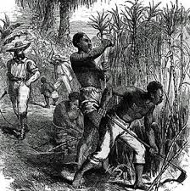
Sugar Cane fields 19th century. Location unknown, possibly Caribbean.

