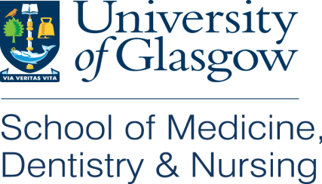

School of Medicine, Dentistry & Nursing

Application to MBChB Year 3 entry
For Dentistry graduate applicants only

Thank you for your interest in the University of Glasgow Undergraduate Medical School.

Please complete this application form and send to med-sch-admissions@glasgow.ac.uk by 15 October 2020 at the very latest for entry in September 2021.

Course: A100 MBChB

All personal information should be entered as it appears on your identification documents.

Personal Information

Title (Mr/Mrs/Miss/Ms)
Surname/Family Name
Forename(s)
Date of birth
Male/Female

Correspondence address
Home address (if different)
Telephone
Mobile
Email (required)

Country of birth

Area of permanent residence

Nationality

Ethnic origin (optional)

Fee payer
(Private Finance, Government Award)

Disability or additional support requirements  (including dyslexia/medical condition) | Y/N (please select)  If yes, please specify disability  or condition
Criminal Convictions  (criminal conviction, caution or reprimand) | Y/N (please select)
GDC Registration Number

Education Details (High School, College, University)

Institution | Start Date | Finish Date

Academic Qualifications Obtained

Year | Name of  qualification | Subject | Grade  achieved | Institution

Academic Qualifications Pending
Year | Name of  qualification | Subject | Grade  achieved | Institution

Have you applied for any courses via UCAS for entry in 2021 (please circle)? Yes No

If yes, please provide your UCAS ID number __________________

Do you currently hold an offer of a place via UCAS for entry in 2021 (please circle)? Yes No

Offers cannot be made to applicants holding an offer elsewhere via UCAS. Please contact us if you wish to discuss this further.

Personal Statement
Reason for applying, suitability, relevant skills and experience

Reference

Please send a copy of your transcript and two references from your most recent education provider or employer with this application form (please send a scanned copy of the original to med-sch-admissions@glasgow.ac.uk with the original signed reference to be sent by post).

I can confirm that all the information provided is accurate

Signature: ______________________________________________ Date: ______________

Thank you for your application.
We will process as soon as possible and communicate with you by email.

