Making Excel Workbooks Accessible

Guidance for University of Glasgow Teaching Staff

Table of Contents
1. What We Must Do: Our Legal Obligations 2
2. How to Meet Our Legal Obligations 3
2.1. Structure 3
2.2. Tables 4
2.3. Links 4
2.4. Images 4
3. Using Excel’s Accessibility Checker 5
3.1. What it does 5
3.2. How to use it 5
3.3. If your workbook has issues 6
3.4. If your workbook has no issues 6

What We Must Do: Our Legal Obligations
The University wants to ensure the digital information we make available through all our portals is accessible to the vast majority of our users: current and prospective students/staff, funders, collaborators and the wider public.
In addition, we have legal obligations under the Equality Act 2010, and new Digital Accessibility Regulations 2018.
These regulations require that any material you post online in the course of your work for the University of Glasgow (e.g. Excel workbooks posted to Moodle) must be all of the following things to all of your students:
- Perceivable
- Operable
- Understandable
- Robust
You can learn more about exactly what these four terms mean, along with examples, on the UofG Digital Accessibility webpages: www.gla.ac.uk/myglasgow/digitalaccessibility.
However, if you are using Office 365, these legal obligations can be easily met if you use the in-built accessibility checker.
The checker is extremely simple, and it recommends remedies to make your documents compliant. See page 5 for an example of how it works.

Note: If you are uploading your workbook to Moodle, do not convert to PDF. Upload your workbook in .xls or .xlsx format. This allows students to adjust font sizes to suit, examine cell formulas, and generally improves compatibility with assistive technologies that your students may be using.

How to Meet Our Legal Obligations
The full list of accessibility standards would be too long to publish in a short guide, but these steps will help you avoid common issues for Excel workbooks.

Structure
‘Headings’ in Excel are a tool to quickly apply standardised formatting options to multiple similar cells at the click of a button. Other Styles are also available.
- With your cursor in the relevant cell, apply a Style from the Home tab
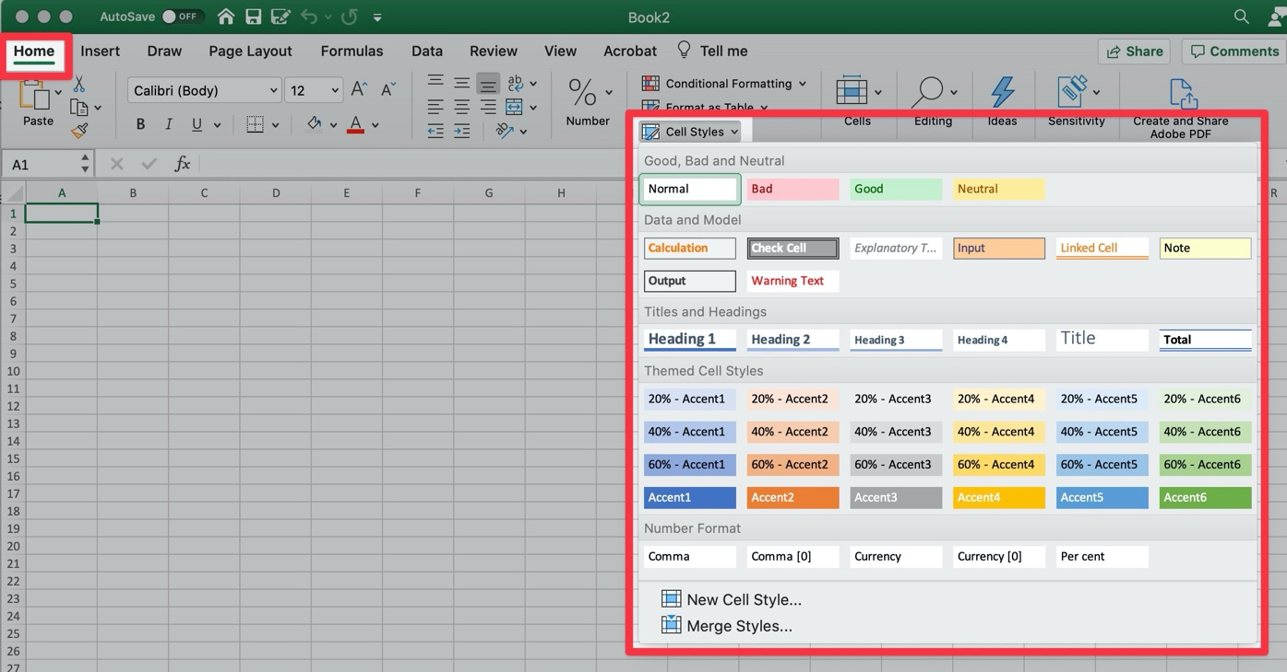
  - This consistency can improve ease of navigation for your students.
- Merge cells to make headings clearer
- Name your worksheets
- Add metadata to your spreadsheet
- Use a contrast checker to avoid colours that cause an issue with colour blindness, e.g. red/green and blue/yellow combinations

Tables
- Use a simple table structure and include column headers
- Avoid the use of split cells, merged cells, or nested tables
- Don't have any completely blank rows or columns
- Add alt text to your table

Links
- Add meaningful hyperlink text. Links should convey clear and accurate information about the destination.
  - Assistive technologies may present students with a list of all the links in a , so imagine that your hyperlink is going to appear without the surrounding text.
  - For example, instead of hyperlinking the text ‘Click here’, include the full title of the destination page: ‘Read more about creating accessible documents on the University of Glasgow Digital Accessibility webpages.’

Images
- Include alternative text with all visuals
  - Briefly describe the image, and mention the existence of any text and its intent
- Avoid using text in images as the sole method of conveying information. If you must use an image with text in it, repeat that text in the workbook.
- For examples, open the Alt Text pane on any of the images in this guide

Using Excel’s Accessibility Checker

What it does
The checker tells you how to fix any issues, which it classifies into four categories:
- Errors
  - Content that will be impossible, or very difficult, for someone with a disability or assistive technology (e.g. a screen reader) to use
- Warnings
  - Content that will likely be understood, but with difficulty
- Tips
  - Suggestions that will improve the experience for users
- Intelligent Services
  - Assigned wherever the software has automatically applied a solution, and you should therefore check that this has been done appropriately
A full list of the accessibility rules that could generate an error message is available from Microsoft Office Support.

How to use it
Create your workbook with the accessibility checker open from the start.
This will help you spot issues the first time you create them, allowing you to avoid replicating them.
To start, click Review > Check Accessibility:
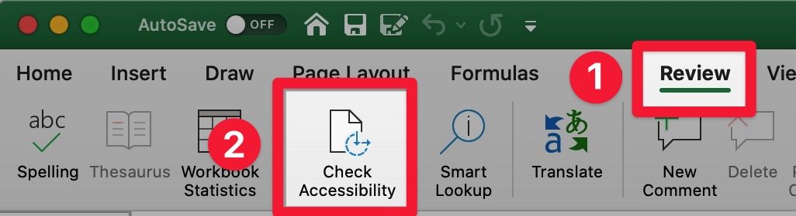

If your workbook has issues

The checker will:
- Categorise issues by severity
- Tell you how to resolve each issue
- Allow you to click each issue to jump directly to its location
- Explain the impact of each issue for your students

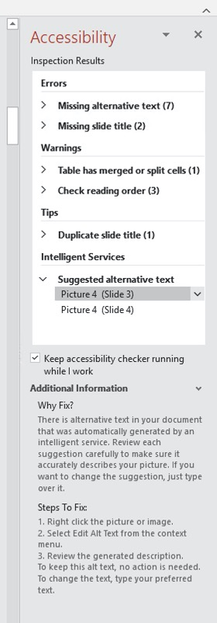

If your workbook has no issues

If / when your workbook is free of issues, you will be told:
‘No accessibility issues found. People with disabilities should not have difficulty reading this workbook.’
