Colleagues guide to updating Diversity data in HR Payroll Portal/PeopleXD

Log in to HR Payroll Portal
To Access/log into HR Payroll Portal visit the HR page of the University website and click ‘Access HR Payroll Portal’. Your GUID and password are your log in details.
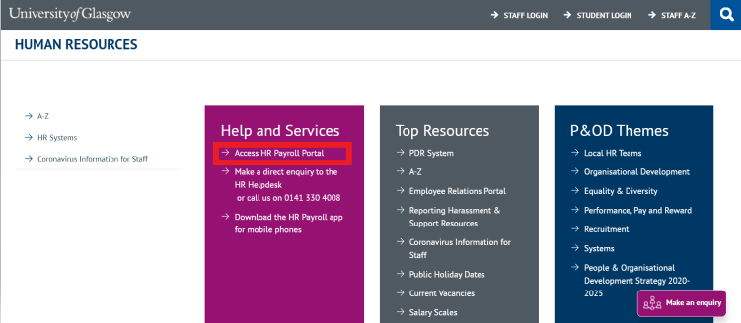
Please note: When you first log in you may arrive at a different Dashboard from that of your colleague - this will depend on your system access.

Employee View
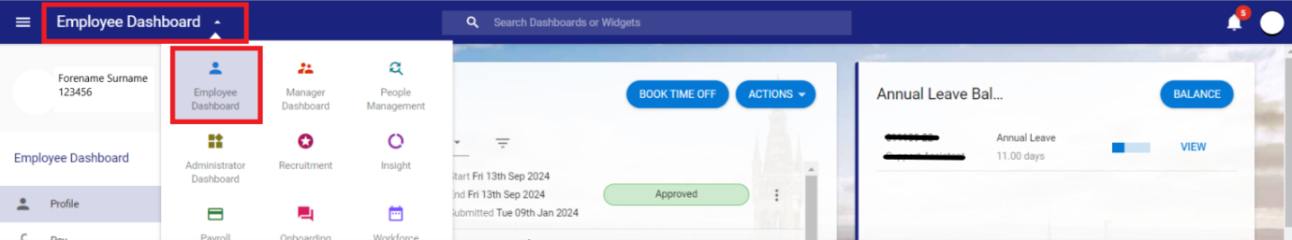
Navigate to the employee dashboard by clicking the dropdown menu in the top left of the screen.
Basic information will be displayed.

Update Personal Details
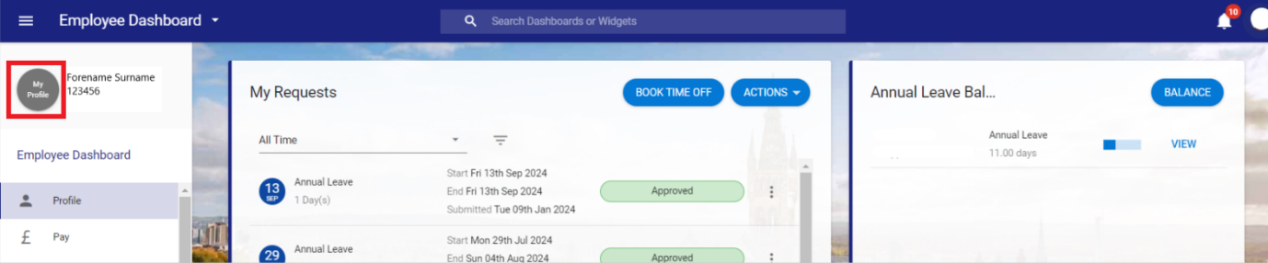
Click on your image (or initials if you do not have an image) below the dashboard dropdown.
Your Personal Profile will open on your contacts tab.

Diversity Details
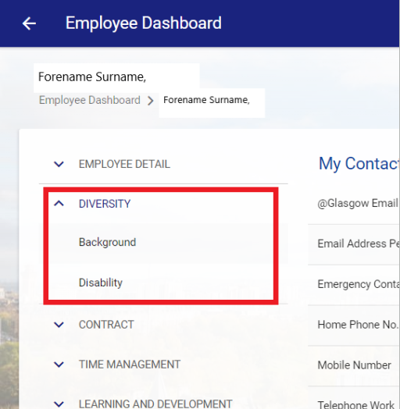
From the menu on the left, select the Diversity menu.

There are 2 tabs within the Diversity menu, please ensure that you check and update the information on both tabs.
Background
In the Background screen, you can update fields such as:
- Gender Identity
- Sexual Orientation
- Ethnic Origin
- Pronouns
- Religion
- Carer Status
- Date of Marriage
- Previous Surname
- Parent/ Guardian
Please note some of the fields are non-editable, such as Sex and Nationality, and can only be updated by your local P&OD team.
Disability (includes long term health conditions)
Even if you are not disabled or have a long-term health condition knowing this helps the University to develop our strategic plans, policies and resources.

Please note this information is not automatically made available to your line manager.
- If you wish to discuss any workplace needs (reasonable adjustments) relating to your disability or health condition tick the ‘Request an Adjustment Conversation’ box.

This will send an automated message to your line manager to set up a discussion and all parties are signposted to the available resources to support constructive dialogue.

- You can enter information about any equipment which you may feel is required or evacuation/safety measures.
Note: this does not replace the option to discuss adjustments at any other point, which is the recommended route, as it also allows for tracking the progress of related dialogue/adjustments (i.e. that meetings have taken place) and supports the setting of periodic reminders to review adjustments.
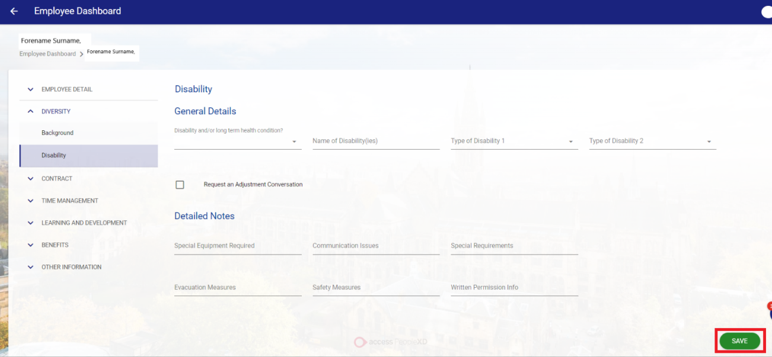

When finished press the save button in the bottom right of the screen.

