Making PowerPoint Presentations Accessible
To make a presentation accessible, follow the six principles of SCULPT:
- Structure
- Colour
- Use of Images
- Links
- Plain English
- Tables

Checking Your Content: using PowerPoint’s Accessibility Checker
These principles are also outlined on the University of Glasgow Digital Accessibility page.

Available Accessible Templates
Using a template can address many of the accessibility issues of presentations.
Promotional materials - accessible PowerPoint templates (University of Glasgow)

Structure
A typical PowerPoint presentation will have:
- A slide title on every slide with the recommended size of between 28 and 44 pts depending on the content;
- A consistent layout;
- Sans serif fonts (for example; Arial, Helvetica, Verdana, and
- Calibri);
- Text with the recommended size 24 and 28 pts depending on the content;
- Bullet points with the recommended number of no more than 4 per slide;
- Use Notes rather than trying to put everything on the slide.
- Keep transitions and animations simple and to a minimum.

Going Further with Structure

Slide Master
Using the Slide Master means changes can be made to groups of slides within a presentation, all at once. For example, the text size of all slide titles, based on the same slide template, can be set to the same size.
Video: Using the Slide Master.

Colour
- Ensure that there is sufficient contrast between the text colour and the background colour. Using an accessible template can ensure the contrast is sufficient.
- Choose Automatic as the text colour to ensure the text will be readable in High Contrast Mode or Inverted Mode
- If you do use colour in a PowerPoint document, try looking at your document in grayscale to check for sufficient contrast.
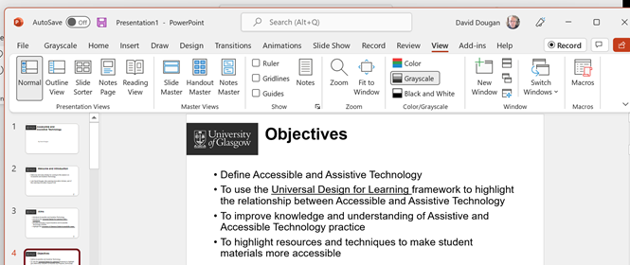

Going Further with Colour
Color Contrast Checker - TPGi
WebAIM: Contrast Checker

Links
Add meaningful hyperlink text. Links should describe the destination of the link.
For example, instead of hyperlinking the text ‘Click here’, include the full title of the destination page: ‘University of Glasgow - MyGlasgow - Digital Accessibility.’

Use of Images
Include alternative text with all visuals that convey information.
Briefly describe the image. Imagine trying to describe the image over the phone.
Avoid using text in images as the sole method of conveying information. If you must use an image with text in it, repeat that text in the document.

Going further with Alt Text
Alt Text creation advice (gov.uk)

Plain English
- Consider the level of study or knowledge of your audience;
- Explain all acronyms, for example, “. . . the Learning Innovation Support Unit (LISU)”;
- Explain complex terms in a glossary slide perhaps at the beginning of the presentation or define them when you first use them.

Going Further with Plain English
Microsoft Editor, spelling and grammar checker (microsoft.com)

Tables
- Use a simple table structure and include column headers;
- Avoid the use of split cells, merged cells, or nested tables;
- Don't have any completely blank rows or columns;
- Include a Header row for your table;
- Add alt text to your table;
- Check that you can navigate the table by the Tab key.

Checking Your Content: using PowerPoint’s Accessibility Checker
The Accessibility Checker runs in the background during document creation. If the Accessibility Checker detects accessibility issues, a reminder appears in the status bar.
The checker tells you how to fix any issues it finds:

Errors
Content that will be impossible, or very difficult, for someone with a disability or assistive technology (e.g. a screen reader) to use

Warnings
Content that will likely be understood, but with difficulty

Tips
Suggestions that will improve the experience for users
This link contains a full list of the accessibility rules (microsoft.com) that could generate an error message.
It is important to remember that the Accessibility Checker is not perfect, and a human check is the best way to identify SCULPT accessibility issues.

How to use the Accessibility Checker
To start, click Review > Check Accessibility:
If your document has accessibility issues the checker will:
- Categorise issues by severity
- Tell you how to resolve each issue
- Allow you to click each issue to jump directly to its location
- Explain the impact of each issue for your students
When your document is free of issues, you will be told: ‘No accessibility issues found. People with disabilities should not have difficulty reading this document.’

Reading Order
Because PowerPoint works with blocks of text, the order in which they are to be read is very important.
To start the Reading Order Check, click Review > Check Accessibility>Reading Order Pane.
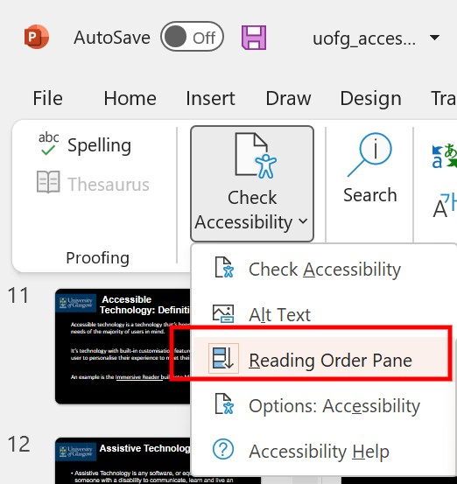
The elements on the page will be given a number to indicate the reading order.
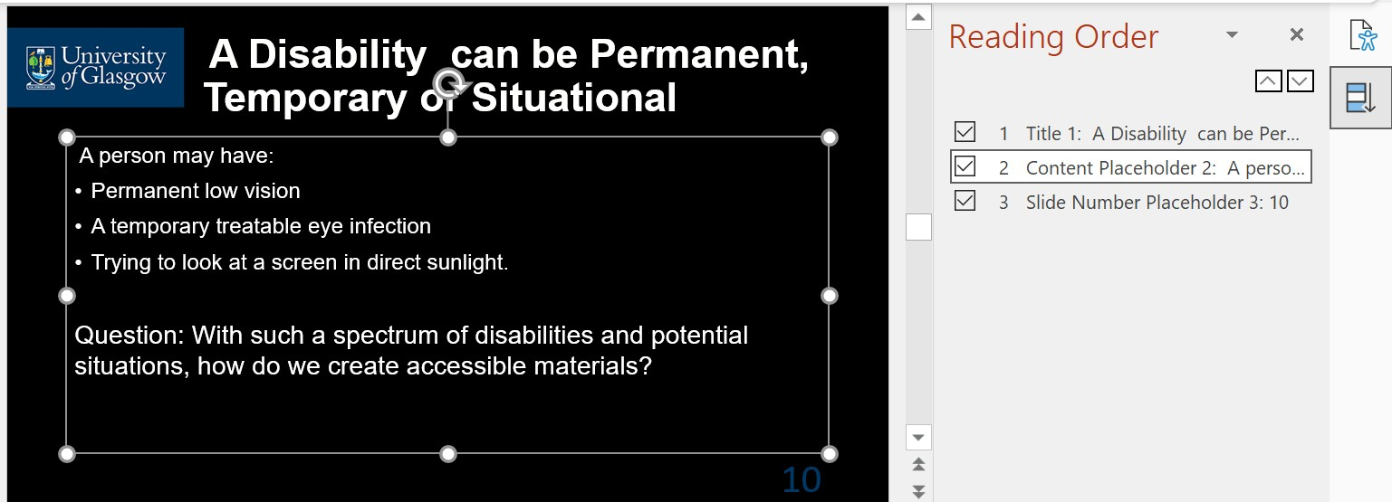

Use the arrows in the Reading Pane to change the Reading Order.
The pane will show every object on the slide. Highlighting an object in the pane will also highlight it in the slide.

