MRC/CSO Social and Public Health Sciences Unit Consultation Response

Title of consultation
Prevention in health and social care
Name of the consulting body
UK Parliament Health and Social Care Committee
Link to consultation
https://committees.parliament.uk/work/7205/prevention-in-health-and-social-care/
Why did the MRC/CSO Social and Public Health Sciences Unit contribute to this consultation?
At the MRC/CSO Social and Public Health Sciences Unit we develop and use cutting-edge methods to understand how social, behavioural, economic, political and environmental factors influence health. We work with decision makers, practitioners and the public to identify ways of achieving sustained improvement in health and wellbeing, particularly among those most in need.
Our consultation response
We welcome the Health and Social Care Committee’s Inquiry into prevention and would like to propose two topics for the Inquiry to consider.

(1) Action on childhood poverty and deprivation to reverse the recent widening of health inequalities
Tackling deprivation and poverty, particularly in childhood, holds powerful potential to improve population health. If the most deprived 50% of areas in England and Wales had the same death rates as the least deprived 50%, 77,000 premature deaths would have been prevented in 2018[1]. Our recent report on health inequalities in Scotland found that residents of the most deprived fifth of areas are at least twice as likely to die from each cause of mortality considered as those in the least deprived fifth[2]. The findings of this report and evidence from other UK countries demonstrate why intervention on this area is urgently needed.

Now is a critical time for Government action, with many health outcomes worsening in the most deprived areas yet improving in less deprived areas, leading to a widening of inequalities. Infant mortality has risen in the most deprived areas of Scotland and England since 2014 [2, 3], with rising child poverty rates identified as a driving factor[3]. Such inequalities in health are not inevitable. Between 2000 and 2012, absolute inequalities in mortality narrowed for many causes of death across Scotland, England and Northern Ireland [4], including infant mortality in Scotland [2]. The subsequent decline in health and
widening of inequality can be reversed, but this requires urgent improvements to the conditions in which people live and grow up.

Deprivation in childhood matters because poor health at this age is a precursor for future problems. Healthy development during the early years supports subsequent health and wellbeing, as well as social outcomes like schooling and employment[5]. For this reason, the early years are considered one of the most effective periods in which to intervene to support population health[6]. However, in the UK, health inequalities are apparent from birth and are widening for many child health outcomes. Our report shows that the prevalence of ‘low birthweight’, delayed childhood vaccination, childhood obesity, and poor adolescent mental health are all increasing among the most deprived areas of Scotland (Figure 1) [2]. As one in five children in England experience poverty [7], these problems are by no means confirmed to Scotland.

The evidence in our report shows that actions to address health behaviours and health service outcomes, while important, will be insufficient without action to address deprivation. Inequalities in health behaviours do not always follow the same pattern as health and mortality outcomes. Children living in deprived areas are more likely to be obese, but are just as physically active as their more advantaged peers[2]. Disadvantaged groups experience worse consequences from health-risk behaviours, due to the presence of other health-harming factors, such as food insecurity and the stress of living on a low income.
While addressing health-risk behaviours and improving health and social care services are important, action on deprivation is essential for the benefits to reach the entire population.

In conclusion, to improve population health and prevent a further widening of health inequalities, urgent action is required to address childhood poverty and deprivation. The Health and Social Care Committee should identify which policy levers the Government could best utilise to address these issues, with reflection on what caused the narrowing of inequalities in mortality between 2000 and 2012 and what has driven the widening of inequalities since then.

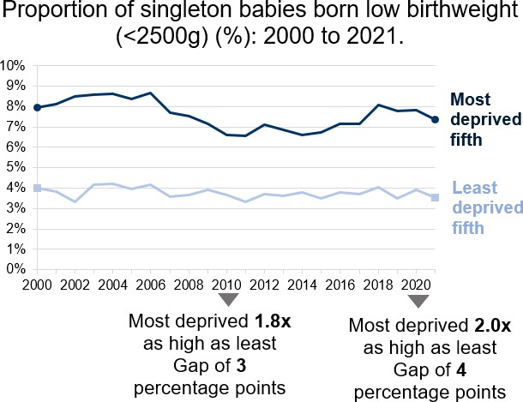

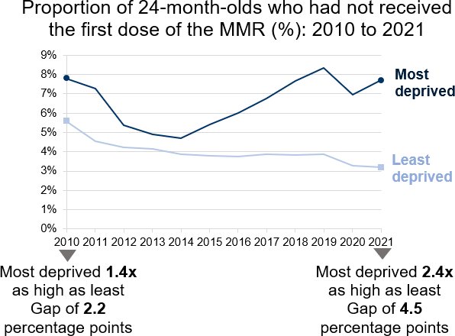

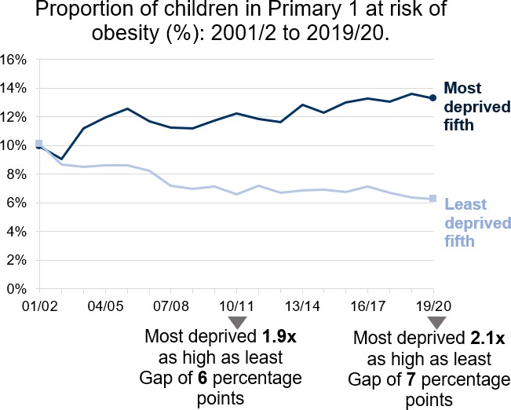

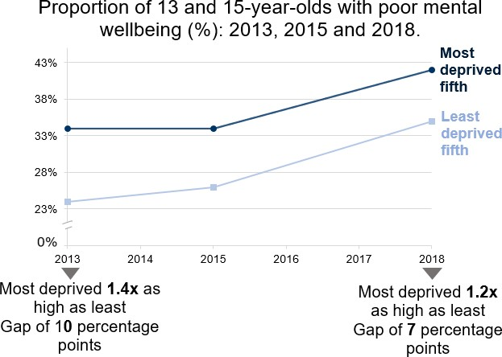

Figure 1: The prevalence of babies being born ‘low birthweight’, delayed childhood vaccination, childhood obesity, and poor adolescent mental health are all increasing among the most deprived areas of Scotland.

2) What governance and decision-making arrangements are needed to ensure that prevention is where it should be by 2030

As well as identifying specific actions to address health inequalities, we recommend that the Committee consider how prevention policies should be developed and implemented, and at what level of Government responsibility should lie. Prevention is often considered as a way of reducing healthcare costs or easing pressure on services. This is too narrow a perspective.
Preventive interventions may be worthwhile even if they are not cost saving [8], especially in the short term.

We welcome the Committee’s recognition that prevention policies should be developed and implemented from a long term perspective. We also urge the Committee to consider whether local or regional policy-makers are best placed to decide how to address the social and economic determinants of health in their populations. Recent research has shown that devolution of powers to Greater Manchester led to improvements in life expectancy relative to the rest of England, and that the benefit was greater in more deprived parts of the region [9]. There has been some devolution of powers to regional governments in England over the past decade, but local governments are tightly constrained by their lack of fiscal autonomy – raising a tiny fraction of their revenue locally by comparison with other European countries [10] yet fiscal decentralisation is linked with better economic growth across OECD countries [11]. Under the current UK system, local governments must raise funds by bidding repeatedly for relatively small amounts of resource, on terms decided by central government. Some policies that affect
health (such as social security policies) must be implemented nationally, with limited scope for local variation. However, the Committee should consider whether greater powers to raise

money and decide priorities could help local or regional governments address housing, transport, employment, and other social and economic determinants of health more effectively, and with greater attention to their populations needs and priorities, than they can at present.

References

- Tinson, A. and Tallack, C. Deprivation and excess deaths: Reducing inequalities in mortality in England. The Health Foundation. Available at: https://www.health.org.uk/news-and- comment/charts-and-infographics/deprivation-and-excess-deaths. [Accessed 31/01/2023].
- Miall, N., Fergie, G., and Pearce, A., (2022.) Health Inequalities in Scotland: trends in deaths, health and wellbeing, health behaviours, and health services since 2000. University of Glasgow. doi: 10.36399/gla.pubs.282637.
- Taylor-Robinson, D., et al., (2019.) Assessing the impact of rising child poverty on the unprecedented rise in infant mortality in England, 2000-2017: time trend analysis. BMJ Open, 9(10): p. e029424.
- Walsh, D., et al., (2020.) Changing mortality trends in countries and cities of the UK: a population-based trend analysis. BMJ Open, 10(11): p. e038135.
- Graham, H. and Power, C., (2004.) Childhood disadvantage and health inequalities: a framework for policy based on lifecourse research. Child Care Health Dev, 30(6): p. 671-8.
- Pearce, A., et al., (2019.) Pathways to inequalities in child health. Arch Dis Child, 104(10): p. 998-1003.
- Pickett, K., et al, (2021.) The Child of the North: Building a fairer future after COVID-19,. The Northern Health Science Alliance and N8 Research Partnership. https://arc- nenc.nihr.ac.uk/news/the-child-of-the-north-building-a-fairer-future-after-covid-19/.
- Cohen, J.T., et al. (2008) Does Preventive Care Save Money? Health Economics and the Presidential Candidates. N Engl J Med, 358(7): p.661-3.
- Britteon P., et al. (2022) The effect of devolution on health: a generalised synthetic control analysis of Greater Manchester, England. Lancet Public Health, 7: p.e844-52.
- The Economist. British cities have far too little power, and it’s holding them back. https://www.economist.com/britain/2022/10/06/british-cities-have-far-too-little-power-and-its- holding-them-back.
- Blöchliger, H. (2013), "Decentralisation and Economic Growth - Part 1: How Fiscal Federalism Affects Long-Term Development", OECD Working Papers on Fiscal Federalism, No. 14, OECD Publishing, Paris, https://doi.org/10.1787/5k4559gx1q8r-en
When was the response submitted?
8th February 2023
Find out more about our research in this area
http://www.glasgow.ac.uk/sphsu
Who to contact about this response
Peter Craig, Professor of Public Health Evaluation, MRC/CSO Social and Public Health Sciences Unit, University of Glasgow
Email: peter.craig@glasgow.ac.uk

